Development of Android-Based Educational Game Learning Media on History Class XI TKJ SMK Islam 1 Durenan

**Ana Aristiyana1), Bian Dwi Pamungkas2)**

1. Information Technology Education, Faculty of Science and Technology, Universitas Bhinneka PGRI, Indonesia

Email address: [anaaris1111@gmail.com](mailto:anaaris1111@gmail.com)

2. Information Technology Education, Faculty of Science and Technology, Universitas Bhinneka PGRI, Indonesia

Email address: sabian.pamungkas@gmail.com

***ABSTRACT- History learning is often considered uninteresting by most students due to its less interactive delivery methods. This is evidenced by the lowest average History score, at 70.525. This score stems from student activeness through attendance and semester learning evaluations. Learning is also hampered by inadequate facilities and infrastructure. Based on the description above, the implementation of the Independent Curriculum is strongly supported by the History subject through the Pancasila Student Profile Strengthening Project. Therefore, the development of educational game-based learning media was developed from online nature exploration activities using the Android platform, as all students have easily accessible Android smartphones. This game is expected to train students in critical learning and increase their participation. Based on previous research, educational games have proven effective in increasing student interest and understanding of History. The study used the ADDIE (Analysis, Design, Development, Implementation, Evaluation) model in developing the learning media. The validation results from media experts and material experts showed that this learning media was very suitable for use with percentages of 91% and 94%, respectively. Small and large group trials also showed very satisfactory results, with percentages of 83% and 91%, respectively. In conclusion, the Android-based educational game developed using the GDevelop application is suitable for use as a history learning medium.***

***Keywords:* *learning media, educational games, android, history***

# INTRODUCTION

The word media comes from Latin, and is the plural form of the word “medium” [16]. The word media itself, comes from the Latin medist which literally means “middle” or “introduction” [20]. Media can be understood as a tool that can send and receive messages or information [18]. Learning media is any form of tool or material used in the teaching and learning process to convey information, ideas, concepts, or skills to students. While the learning process is a communication process and takes place in a system, the learning media occupies a fairly important position as one of the system components [4].

History is a very important subject taught at school. According to the Ministry of Education and Culture [6], History lessons are an important part of the Indonesian Education curriculum because they are part of the diversity and progress of the nation. History is a means of knowledge, in order to know more about events that have occurred and is one of the human references to understand more about history, for example in the history of Indonesian independence [11]. Implementation of the Merdeka Belajar Curriculum provides an appropriate and solid educational foundation for the development of society and the state by making education an important foundation [1].

With regard to the implementation of the Merdeka Curriculum, History subjects take an important role because they can help students build noble characters as expected in strengthening the student profile of Pancasila. Through History subjects, students can understand the development of human civilization, both in Indonesia and in the world, as well as foster a race of love for the country and national identity. According to the Ministry of Education, Culture, Research and Technology in 2024 [6], History remains an important component of the Education curriculum. The Ministry of Education and Culture also emphasizes that History lessons not only function to provide knowledge about the past, but also to form wiser and more responsible citizens.

SMK (Vocational High School) is a formal education unit that organizes vocational education at the secondary level. The purpose of SMK education is to prepare students to be able to work in certain fields after graduation. SMK graduates are expected to become skilled workers who have the ability to meet the demands of the world of work. To improve the quality of SMK education, Kemendikbudristek [6] organizes the SMK Center of Excellence Program (SMK PK), this program aims to prepare Indonesia's young generation to become a superior and competent workforce in the industrial world. With the advantages of SMK that allow graduates to directly enter the world of work, this research aims to develop learning media that can improve the skills and knowledge of SMK students, so that they can compete with SMA and MA graduates.

Through interviews with the vice principal of the curriculum of SMK Islam 1 Durenan on November 15, 2024 which has been carried out, it is known that the number of XI TKJ 2 students is 30 students of these 30 students including 21 males and 9 females. The average student likes games in one class is 60%. Based on the results of observations, of the 30 students I observed there were 28 Android users and 2 IOS users.

Based on observations made by researchers, the lowest average score of all subjects is History where the average student is at 70.525. The value comes from student activeness through attendance and learning evaluations each semester. Learning is also hampered by unsupportive facilities and infrastructure, in the classroom there are no photos of the president and vice president, no photos of heroes, and every presentation the teacher does not provide a projector.

Based on the description above, the implementation process of Merdeka Curriculum is strongly supported by History subjects through the Pancasila Student Profile Strengthening Project. Therefore, the development of educational game-based learning media, which was developed from online nature exploration activities using the Android platform, because all students have Android smartphones that are easily accessible. Android is an open source operating system based on the Linux kernel, which allows applications to run on an application framework that controls activities supported by the Dalvik library and virtual machines [14]. This game will train students in a new learning method that demands cooperation between students and critical problem solving.

Based on this background, this study aims to determine the feasibility level of educational game-based learning media on History material for class XI TKJ 2 SMK Islam 1 Durenan. The type of data in research and development used is quantitative and qualitative data. This research is expected to contribute to the development of new learning experience learning strategies and increase student involvement in learning History. In addition, the results of this study can also be a reference for teachers, schools, as a tool in the process of teaching and learning activities in the History class XI TKJ2 SMK Islam 1 Durenan.

# RESEARCH METHODS

This type of research is research that will develop student learning evaluation media in the form of application-based educational games, known as *Research and Development* (R&D). Development research covers a series of processes that aim to develop existing or new products. The steps of this process are usually called the *Research and Development* cycle which consists of several steps including analyzing the product to be developed, the development process, product trials to the revision and evaluation stages to improve product weaknesses.

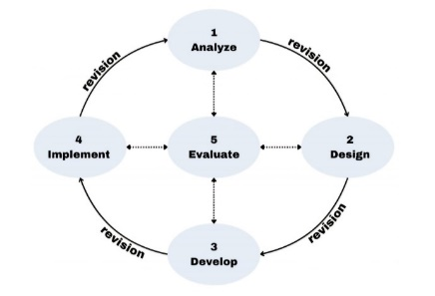

Figure 1 ADDIE Development Model

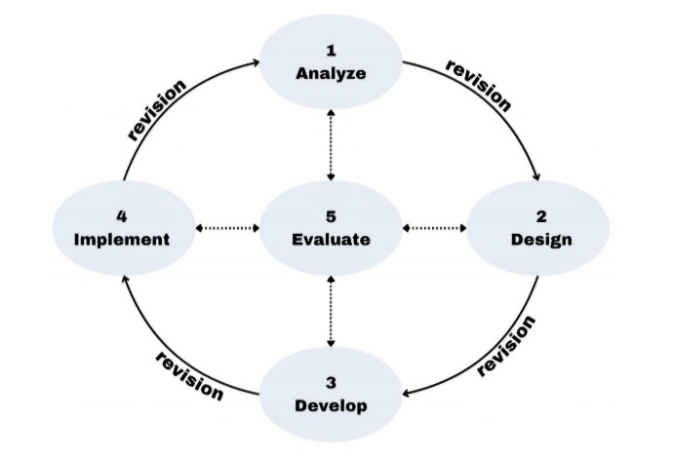 In this study, researchers used the ADDIE model which has 5 stages: *Analysis, Design, Development, Implementation, and Evalution*. The ADDIE research model is one of the instructional development models that is often used in learning and training. In the development process, it requires several tests by a team of experts, individual research subjects, limited scale and wide scale or field, and revisions to improve the final product [13]. The first stage of Analysis, the analysis stage is carried out to determine learning needs, characteristics of students, and set clear learning objectives [2]. The second stage Design, at this stage planning is carried out starting from the selection of methods, learning strategies, media design, to the evaluation that will be used [17]; The third stage Development, development is carried out by making products according to design, then validation by experts and product trials to get feedback [7]; The fourth stage Implementation, the implementation stage is the process of using learning media that has been developed on real subjects [9]; The fifth stage Evaluation aims to determine the effectiveness of the media, it can be a formative evaluation during the process, and summative after the media is applied [8].

# RESULTS AND DISCUSSION

The following is a description of the development that has been carried out using the ADDIE stage:

## *Tahap Analysis*

The analysis stage in the ADDIE model aims to identify the needs and characteristics of students and the learning objectives to be achieved [15]

At this stage, the research carried out a needs analysis with the aim of identifying the obstacles faced in the learning process in the History learning activities of class XI TKJ 2 at SMK Islam 1 Durenan. After the relevant data and information were collected, the researcher attempted to formulate a comprehensive solution to overcome these obstacles. The analysis process was conducted through two main approaches, namely observation and interviews.

Observations were conducted directly and interviews were conducted indirectly. Direct observation involved observing learning activities in the classroom environment and outside the classroom. This observation resulted in the finding that there were 30 students in class XI TKJ 2, 21 males and 9 females. It is known that 28 students use Android smartphones and 2 students use IOS. In addition, researchers found that when the learning process took place, many children did not focus on listening to the learning delivered by the teacher but played their own cellphones, mostly they used cellphones to play games.

Meanwhile, interviews were conducted by monitoring the learning process of students through online communication with the homeroom teacher of class XI TKJ2. It was found that the teaching methods used were not very interesting to the students. The learning process implemented by the teacher was PBL (*project-based learning*), where students presented their findings in front of the class. However, the teacher did not provide laptops and projectors for the presentations, so students had to present using paper. The teacher did not make full use of media that could maximize the delivery of material, resulting in less than optimal learning.

## *Design Stage*

The design stage is the stage of designing a product based on the results of the needs analysis that has been conducted. In the design stage, the learning framework is designed, including the determination of specific objectives, learning strategies, media to be used, and evaluation instruments [12].

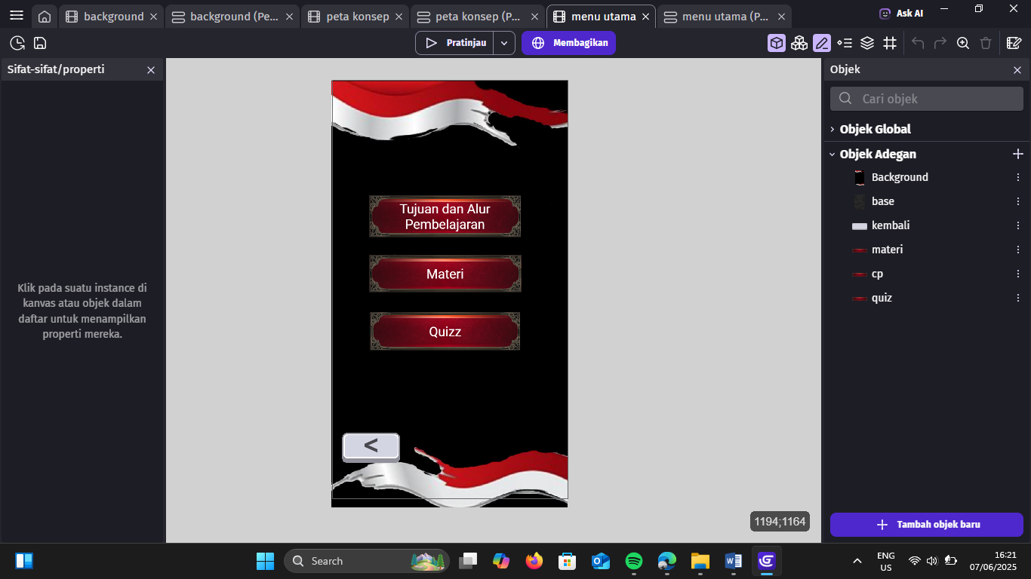

Figure 2 Adding assets in Gdevelop

The process of creating application assets begins with selecting buttons that are suitable for the design and functionality of the product. After that, the necessary algorithms are applied to determine how the application will respond to user interactions.

## *Development Stage*

In the development stage, there is a series of processes to create or refine a product. The development stage focuses on creating and producing teaching materials based on the design that has been created, such as modules, interactive media, and worksheets [19]. After analyzing the needs and designing a product that meets the expectations of potential users, the next step is the implementation stage, where the product begins to be developed through the programming process. This stage focuses on applying the design concept into a usable form, ensuring that each feature works according to its original purpose.



Figure 3 Title page

The application title page has a login button to start the application. At this stage, a START button is added to the page to start logging into theapplication.

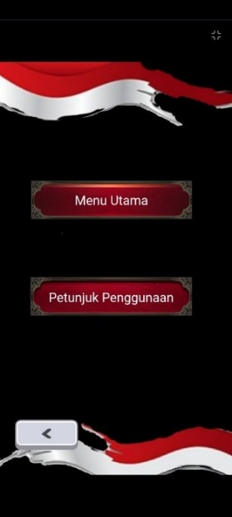

Figure 4 Menu Page

Figure 4 Menu page, there are two buttons, namely the main menu and usage instructions. The main menu button is used to access the TP/ATP page, materials, and quizzes. The usage instructions button is used to switch to the usage instructions page. There is a back button to return.

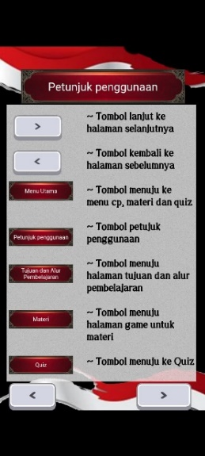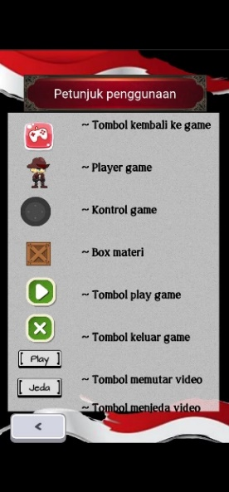

Figure 5 User Guide Page

Figure 5 Menu page, there are two buttons, namely the main menu and user guide. The main menu button is used to access the TP/ATP page, materials, and quizzes. The user guide button is used to switch to the user guide page. There is a back button to return to the previous page.

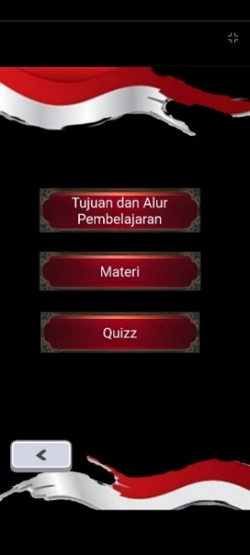

Figure 6 Main Menu Page

Figure 6 Main menu page, there are three buttons, namely learning objectives and flow, materials, and quizzes. There is a back button to return to the previous page.

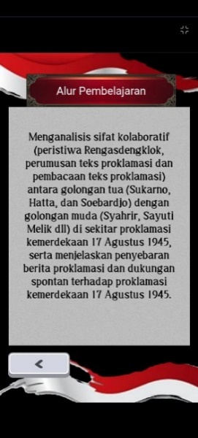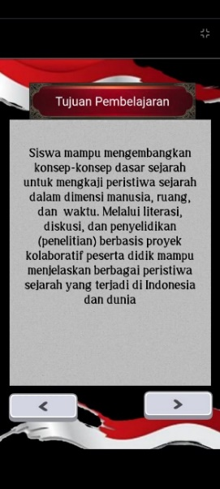

Figure 7 Learning Objectives Page

Figure 7 learning objectives and flow. There are next and back buttons to proceed or return to the next page.

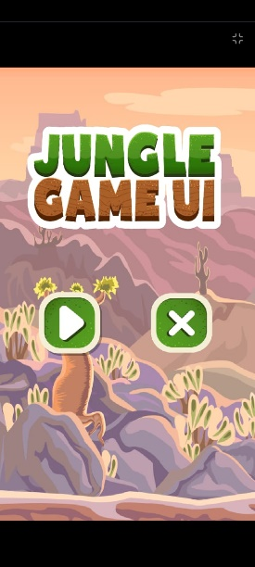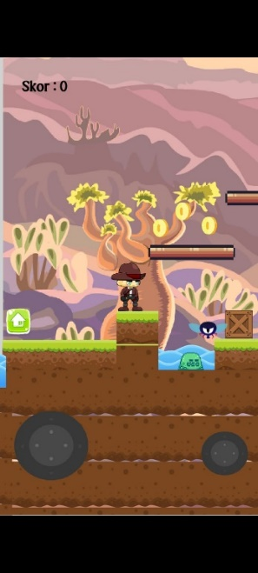

Figure 8 Game Page

Figure 8 Game page, there are 2 buttons. The play button on the game menu is used to enter the game page and the exit button is used to return to the main menu page. On the game page, there is a player as the game player. In the game, a material box asset is added. When the player hits the material box, the user will enter the material page. There is a home button to exit the game page.

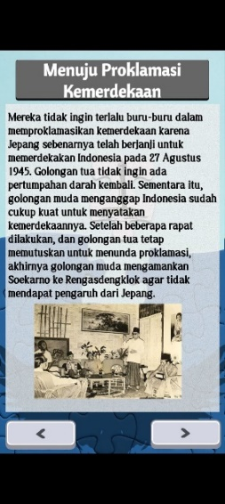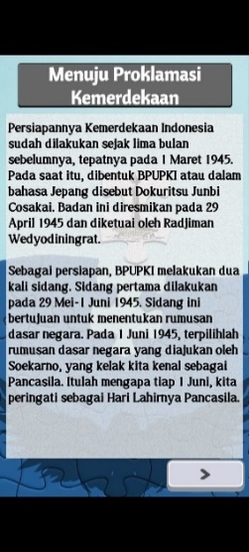

Figure 9 Material Page

Figure 9 shows the material page, which presents material in accordance with the teaching module and includes images to support the learning material. This page also includes back and forward buttons. These buttons are used to move forward or backward to the next page.

This educational game learning media was distributed and tested on students in class XI TKJ2 at SMK Islam 1 Durenan. The media was first tested for validity by subject matter experts and media experts before being field tested. Subsequently, field tests were conducted on small and large groups.

Expert validation was conducted to assess the content and design of the developed materials and media. Media expert validation was carried out by a lecturer from Bhinneka PGRI University in Tulungagung, while subject matter expert validation was conducted by the history teacher of TKJ2 at SMK Islam 1 Durenan.

TABLE I. VALIDITY TEST

|  |  |
| --- | --- |
| Media Expert | Material Expert |
| 91% | 94% |
| Category “Highly Recomended” | Category “Highly Recomended” |

Based on Table 1, the assessment by media experts obtained a score of 91%, while material experts obtained a score of 94%. Therefore, it can be concluded that both have a rating of “Very Good.”

## *Implementation Stage*

Implementation is the stage where the developed design and product are tested or directly applied in the learning process with students [5]. After passing validation tests by media experts and subject matter experts, the product was tested on students in class XI TKJ2. This testing process consisted of two stages, namely small group testing and large group testing. The small-group testing phase was conducted on June 11, 2024, involving 5 students. Based on the percentage of feasibility calculated during the subject matter expert validation, the product achieved an 83% score, which falls under the “Highly Feasible” criteria. The percentage obtained indicates that the product has a high level of feasibility and can proceed to large-group testing.

The large group trial was conducted on June 12, 2025, with 19 students. Based on the results of the large group trial, a feasibility percentage of 89% was obtained, which falls within the “Very Feasible” criteria in accordance with the feasibility percentage. The percentage obtained shows that the product is very feasible for use as a learning medium for History class XI TKJ2 SMK Islam 1 Durenan.

## *Evaluation Stage*

The evaluation stage is the final stage in the ADDIE model. Evaluation is carried out to assess the effectiveness, efficiency, and appeal of the learning product that has been developed, as well as to identify areas that need improvement [10].

Testing and Data Collection

1. Product Testing: After undergoing validation by media experts and subject matter experts, the product was tested on students in class XI TKJ2 at SMK Islam 1 Durenan. The testing was conducted in two phases: a small group and a large group.
2. Data Collection: Data was collected through a questionnaire filled out by students after testing the product. The questionnaire included statements regarding usage, appearance, content, and student satisfaction with the product.

Data Analysis:

1. Small Group Test: A small group test was conducted on 5 students, resulting in an 83% feasibility percentage, indicating that the product has a very high level of feasibility for use. Several aspects received scores below 4 due to installation constraints and differences in each child's design preferences.
2. Large-Scale Group Test: A large-scale group test was conducted on 19 students, resulting in an 89% feasibility rate. Some aspects scored below 4 due to poor internet connectivity for installing the product, full student memory, and varying design preferences among students.

# CONCLUSION

1. The development of this History learning media uses the GDevelop application to create product assets, with the assistance of Canva to create the background. The ADDIE (*Analysis, Design, Development, Implementation, and Evaluation*) development model was chosen because of its systematic process and the ability to evaluate at each stage. Thus, the learning media can be tailored to user needs and achieve effective learning objectives.
2. The feasibility level of the learning media based on the product trial results was conducted after the validation instruments by media experts and subject matter experts were deemed valid. The validation test results showed that media experts gave a rating of 91%, while subject matter experts gave a percentage of 94%. The trial phase was conducted in stages, starting with a small-group trial and followed by a large-group trial. In the small group trial, a suitability percentage of 83% was obtained, while in the large group trial, the result reached 91%. Thus, the overall value of the validation and suitability test results shows that this product is “Very Suitable” for use as learning media for History class XI TKJ2 at SMK Islam 1 Durenan.

# REVERENCES

1. Anjani, K. T., Rufaidah, A., & Suharyati, H. (2023). Integrasi filosofi esensialisme dalam Kurikulum Merdeka. *Journal Of Administration and Educational Management (ALIGNMENT)*, *6*(2), 354-365.
2. D. R. Putri, "Pengembangan Media Pembelajaran Berbasis Multimedia Interaktif dengan Model ADDIE," *Jurnal Pendidikan dan Pembelajaran*, vol. 10, no. 1, pp. 22-29, 2021.
3. F. Sari dan M. Munir, "Pengembangan Media Pembelajaran Interaktif Menggunakan Model ADDIE pada Mata Pelajaran IPA," *Jurnal Pendidikan Teknologi dan Kejuruan*, vol. 19, no. 2, pp. 101-108, 2022.
4. Fadilah, N. U. (2019). Media Pembelajaran. *Kemenag*, 1000, 1-6.
5. Fitriani, D., & Suherman. (2020). Pengaruh model pembelajaran ADDIE terhadap hasil belajar siswa pada mata pelajaran matematika. *Jurnal Inovasi Pendidikan Matematika*, 3(2), 110-120.
6. Kemendikbudristek. (2024). Kurikulum Merdeka: Konsep dan Implementasi. *Jakarta:* *Kementerian Pendidikan, Riset, dan Teknologi.*
7. L. P. Astuti, "Pengembangan Media Video Pembelajaran Menggunakan Model ADDIE," *Jurnal Inovasi Pendidikan*, vol. 12, no. 1, pp. 35-42, 2021.
8. M. A. Ramadhan, "Evaluasi Media Pembelajaran Berbasis Video Interaktif dengan Model ADDIE," *Jurnal EduTech*, vol. 7, no. 1, pp. 59-66, 2022.
9. N. Hidayati, "Implementasi Media Pembelajaran Interaktif dalam Pembelajaran Daring," *Jurnal Pendidikan Indonesia*, vol. 11, no. 3, pp. 145-150, 2021.
10. Nurjanah, S., & Setiawan, A. (2019). Evaluasi program pelatihan guru menggunakan model ADDIE. *Jurnal Pendidikan Guru Sekolah Dasar*, 2(1), 40-50.
11. Nuur, Naazil Maharani An, et al. (2023) "Analisis Frasa dalam Kisah Sejarah pada Buku Ilmu Pengetahuan Sosial Kelas X Kurikulum Merdeka." *Jurnal Riset Rumpun Ilmu Bahasa* 2.2:30-47.
12. Purnamasari, D., & Wahyu, D. (2021). Desain pembelajaran berbasis model ADDIE untuk meningkatkan motivasi belajar mahasiswa*. Jurnal Inovasi Pendidikan dan Pengajaran*, 8(1), 53-62.
13. R.A.H. Cahyadi, "Pengembangan Bahan Ajar Berbasis ADDIE Model", *Halaqa: Islamic Education Journal*, vol. 3, no. 1, pp. 35-43, 2019.
14. Raditya, M. K. (2023). Evolusi sistem operasi Android: Sebuah tinjauan literatur. Jurnal Pelita Teknologi, 18(1), 65-74
15. Rahim, A. (2020). Pengembangan model pembelajaran blended learning berbasis ADDIE pada mata kuliah media pembelajaran. *Jurnal Edukasi Nonformal*, 1(2), 1-10.
16. Rohani, R. (2020). Media pembelajaran.
17. S. Widodo and R. Wahyuni, "Desain Pengembangan Media Pembelajaran Interaktif Menggunakan Model ADDIE," *Jurnal Teknologi Pendidikan*, vol. 8, no. 2, pp. 87-95, 2020.
18. Saleh, M. S., Syahruddin, S., Saleh, M. S., Azis, I., & Sahabuddin, S. (2023). Media pembelajaran
19. Sari, I. M., & Wati, F. M. (2022). Penerapan model ADDIE dalam pengembangan media pembelajaran interaktif pada mata pelajaran sejarah. *Jurnal Pendidikan Sejarah Indonesia*, 5(1), 75-85.
20. Wulandari, A. P., Salsabila, A. A., Cahyani, K., Nurazizah, T. S., & Ulfiah, Z. (2023). Pentingnya media pembelajaran dalam proses belajar mengajar. *Journal on Education*, 5(2), 3928-3936